



**RESEARCH METHODS ASSIGNMENT I**

|  |  |
| --- | --- |
| **Group members** | **Id no** |
| **Alpha Lencho** | **UGR/5792/14** |
| **Duresa Guye** | **UGR/3595/13** |
| **Eshetu Assefa** | **UGR/3009/13** |
| **Firomsa Mitiku** | **UGR/5809/13** |
| **Muhammed Ahmed** | **UGR/3098/14** |
| **Tolosa Diriba** | **UGR/9806/14** |

# Table Of Content

Cover page 1

Table Of Content 2

CHAPTER ONE 3

1.1. Introduction/ Background 3

1.2. Overview of the current system 4

1.3 Problem/Opportunity Statement 5

1.3.1 Problem statement 5

1.3.2 Opportunity Statement 5

1.4. Objectives of the project 6

1.5. Feasibility study 8

1.5.1 ECONOMIC FEASIBILITY 8

1.5.2 TECHNICAL FEASIBILITY 14

1.5.3 Operational Feasibility: 17

1.5.4 Legal and Contractual Feasibility: 18

1.5.5 Political Feasibility: 19

1.5.6 Scheduling Feasibility: 19

1.6. Significance of the project 20

1.7. Scope of the proposed system 22

1.8 ESTIMATED BUDGET, TOOL and RESOURCE REQUIREMENTS 22

1.9 Work breakdown structure and Gantt, PERT/CPM Chart 23

1.9.1 Work breakdown structure 25

1.9.2 Gantt Chart 26

1.9.3 PERT/CPM CHART 27

1.10 Risk Management 29

1.11 Communication Plan 32

# CHAPTER ONE

## 1.1. Introduction/ Background

Coffee and ‘selit’ are two of the most important agricultural exports in Ethiopia, contributing to the livelihoods of millions of farmers and generating significant revenue for the country. However, the current system of exporting these products is fraught with challenges and inefficiencies, affecting the quality, quantity, and profitability of the produce. This report aims to provide an overview of the existing system, identify its main problems, and propose a novel solution that leverages digital technology to improve the export process. The proposed solution is called Farmer Exporter bridging system, and it is designed to connect farmers and exporters directly, bypassing the intermediaries that often exploit the farmers and inflate the prices.

Ethiopia is a country with a rich and diverse agricultural heritage, producing some of the finest coffee and sesame (selit) in the world. However, the current system of exporting these products is not optimal, as it involves many intermediaries that reduce the profits of farmers and the quality of products. This report proposes a new system called Farmer Exporter bridging system, which aims to connect farmers and exporters directly through a digital platform. The main goal of Farmer Exporter bridging system is it can improve the agricultural export sector in Ethiopia, and contribute to its economic and social development.

The Farmer Exporter Bridging System project is a digital platform that aims to transform the export process of coffee and selit, two of the most important agricultural commodities in Ethiopia. The project has significant implications for various stakeholders involved in the agricultural export sector, as well as for the country as a whole.

The Farmer-Exporter Bridging System project is a digital platform that aims to transform the export process of coffee and sesame, two of the most important agricultural commodities in Ethiopia. The project involves two main groups of stakeholders: the developers and the end users. The developers are a team of passionate and skilled professionals who want to create a seamless and efficient platform that connects farmers and exporters directly. The end users are the farmers, agents, and exporters who play vital roles in the export ecosystem. We explain how the platform works, what benefits it offers, and what challenges it faces. Wel also provide some recommendations for implementing and evaluating the platform. The main goal of our system is to show how the platform can empower farmers, enhance transparency, and increase the global recognition of Ethiopian coffee and sesame.

## 1.2. Overview of the current system

Within the expansive coffee and selit production landscape in JIMMA, SIDAMA, KAFFA, and GONDER regions of Ethiopia, the existing system is a multi-layered and intricate network that involves numerous stakeholders. Initially, individual farmers employ diverse methodologies, cultivating coffee and selit based on their own unique strategies, resulting in variations in both quantity and quality. With the imperative to meet immediate familial needs, these farmers often resort to selling their yield to local intermediaries at prices that fail to reflect the true worth of their produce.

Following this primary exchange, a sequence of intermediaries assumes responsibility for the products, each adding their own value to the supply chain. This involves an array of activities, including the processing of coffee, such as grinding and washing, if the product is initially sold with its covering or in its fresh state. As the goods pass through each intermediary, a layer of complexity is added, contributing to the incremental growth of the product's value.

However, the extended duration of storage undertaken by some intermediaries, aimed at capitalizing on market price fluctuations, often obscures the transparency of the supply chain. This practice of withholding the products to await optimal selling conditions introduces significant delays, resulting in inflated prices by the time the coffee and selit finally reach the hands of the exporters. This intricate overview of the existing system reveals the numerous challenges and inefficiencies that pervade the current agricultural export process, emphasizing the need for a streamlined and transparent solution to bridge the gap between farmers and exporters.

In conclusion, the traditional Ethiopian coffee and ‘selit’ export system, while fostering a strong sense of community and trust, faces significant limitations due to its reliance on manual and in-person negotiations. This approach has led to inefficiencies, opaque pricing, and communication barriers between farmers and exporters, ultimately impeding fair compensation for farmers. Recognizing the urgent need for change, the proposed Farmer Exporter bridging system seeks to introduce a streamlined and transparent digital system. This innovative solution aims to enhance transparency, efficiency, and equitable practices, fostering improved communication and fair compensation for all participants in mentioned regions’ coffee and ‘selit’ export industry.

## 1.3 Problem/Opportunity Statement

### 1.3.1 Problem statement

The problem in the current system is that there is no means in which farmer directly connect with exporters which result in involvement different in intermediaries to deliver the product that the farmer produces to the exporter.

This involvement of different middlemen and intermediaries is highly impacting both the farmers who is not getting deserved pricing and compensation for the product they are providing and Exporter, who is not getting the quality and quantity they want. It is not only that the farmer is not connecting directly with exporter, there is no environment that creates competition between exporters to buy the products of the farmer which is resulting in the farmer not getting the fair price he/she deserves.

All these factors are in turn affecting the revenue that our country get from the export products. Our system to aims address these problems and looks forward to benefit both the farmer and Exporter and also aims at scaling up the income that our country gets from the exported products.

### 1.3.2 Opportunity Statement

Developing this Farmer-Exporter bridging system highly benefits both the farmer and Exporter and in the bigger picture, Our country.

Within this innovative platform, farmers gain the chance to spotlight their outstanding products, engage in direct negotiations with exporters, and forge equitable agreements devoid of the convoluted layers introduced by intermediaries. This direct interface not only empowers farmers but also bestows upon them a dynamic stage for direct interaction with exporters. In this process, it ensures that their tireless efforts and top-notch produce receive the recognition and fair and deserving pricing they truly deserve. By sidestepping the intermediaries, farmers can preserve a larger slice of the profits, fostering a fairer distribution of economic rewards.

This platform presents a distinct advantage for the Exporters by granting access to an expansive network of producers. This translates to a rich and diverse assortment of top-tier coffee and sesame(selit) products primed for the global stage. With a direct link to farmers hailing from the different regions of the country, exporters can curate a vast selection of premium offerings, tailor-made to meet the unique desires and tastes of international consumers. This direct sourcing prowess not only elevates the quality and variety of available products but also streamlines supply chains, ensuring efficiency and responsiveness. Moreover, by connecting directly with farmers, exporters benefit from greater transparency in the sourcing process, enabling them to establish sustainable and ethical supply chain relationships, which resonate positively with today's socially conscious consumers.

This system's ripple effects extend far beyond individual farmers and exporters, contributing significantly to the overall economic and social development of the country. By fostering direct connections and eliminating middlemen, the platform enhances the efficiency and transparency of agricultural trade, which, in turn, generates substantial macroeconomic advantages.

**Economic Growth:** The removal of intermediaries means that more of the revenue generated stays within the country, thereby increasing the income of farmers. This, in turn, boosts economic growth, reduces income inequality, and provides greater opportunities for entrepreneurial development.

**Agricultural Sector Advancement:** The system bolsters the agricultural sector by encouraging innovation and investment in modern farming practices. Farmers are incentivized to improve the quality of their products, driving overall productivity and competitiveness in the international market.

**Foreign Exchange Earnings:** The expansion of high-quality exports, facilitated by direct connections between farmers and exporters, significantly contributes to a country's foreign exchange earnings. This, in turn, helps stabilize the national economy and supports other critical sectors.

**Rural Development:** As farmers gain direct access to international markets, rural communities benefit from increased income, leading to improved living standards, better access to education, healthcare, and infrastructure. This contributes to reducing rural-urban disparities.

**Global Reputation:** By consistently delivering top-tier products to the global market, the country gains a strong reputation for quality and reliability. This can attract further international investment and trading partnerships.

In sum, the system serves as a catalyst for national development, spurring economic growth, fostering rural development, and enhancing the global standing of the country. It's not just a benefit for individual farmers and exporters; it's a strategic asset in the larger tapestry of the nation's prosperity."

## 1.4. Objectives of the project

1. **Direct Connection and Empowerment of Farmers**:

- The platform will feature detailed profiles of farmers, highlighting their cultivation practices, product quality, and unique selling points.

- Farmers can upload images and videos showcasing their farms and production processes, providing exporters with a comprehensive understanding of the origin and quality of the products.

- Negotiation tools on the platform will enable farmers to set fair prices, creating a transparent and equitable pricing system.

**2. Exporters' Access to Diverse Products:**

- The platform will categorize products based on region, flavor profiles, and processing methods, allowing exporters to easily navigate and discover a wide range of offerings.

- A rating and feedback system from previous transactions will assist exporters in making informed decisions when selecting producers, fostering a competitive environment for quality improvement.

**3. Transparency and Trust Building:**

- Real-time tracking of shipments and quality control measures will be implemented, providing both parties with up-to-date information on the status of their transactions.

**4. Global Marketing and Branding:**

- The platform will have a dedicated section for marketing materials, such as professionally curated photos, videos, and information about the unique characteristics of Ethiopian coffee and selit.

- Exporters can use data analytics tools to identify market trends and consumer preferences, tailoring their marketing strategies to maximize global appeal.

**5. Community and Sustainability Initiatives:**

- The platform will host forums and discussion boards for farmers and exporters to share best practices, innovations, and challenges, fostering a sense of community and collaboration.

- Sustainability certifications and practices will be highlighted, appealing to environmentally conscious consumers and enhancing the overall reputation of Ethiopian agricultural products.

**6. Training and Capacity Building:**

- The platform will offer training modules on best agricultural practices, quality control, and sustainable farming techniques, ensuring continuous improvement in product quality.

- Exporters can access resources on international trade regulations and market dynamics, empowering them to navigate global markets more effectively.

By incorporating these specific features, our digital export platform becomes a comprehensive solution that not only streamlines the export process but also contributes to the sustainable growth and global recognition of Ethiopian coffee and selit.

## 1.5. Feasibility study

### 1.5.1 ECONOMIC FEASIBILITY

The economic feasibility assesses the financial viability and cost-effectiveness of the proposed system. Determining Project Benefits:

The information system can provide various benefits to the organization and stakeholders involved. These benefits can be both tangible and intangible. Tangible benefits are those that can be measured in monetary terms and with certainty. Some examples of tangible benefits for the "Farmer Exporter Bridging System" project includes:

**1.5.1.1 Cost-Benefit Analysis or Cost reduction and avoidance:** Evaluate the potential costs associated with developing, implementing, and maintaining the digital platform. This includes infrastructure costs, software development expenses, ongoing technical support, and operational costs. Compare these costs with the anticipated benefits and returns on investment (ROI) that the system is expected to generate. By eliminating intermediaries and improving the efficiency of the supply chain, the project can lead to reduced costs in transportation, storage, and handling of agricultural products.

The "Farmer Exporter Bridging System" project aims to revolutionize the coffee and sesame trade in Ethiopia's Oromia, Sidama, and Amhara regions by connecting farmers directly with exporters. One of the key benefits of this system is the potential for significant cost reduction and avoidance throughout the supply chain.We provides an analysis of the estimated financial impact resulting from these cost-saving measures.

* **Transportation Costs:**

Currently, the traditional trading system involves multiple intermediaries, leading to higher transportation costs. With the "Farmer Exporter Bridging System," direct connections between farmers and exporters can significantly reduce transportation expenses.

Based on industry data and market research, it is estimated that transportation costs can be reduced by approximately 30% through the elimination of intermediaries.

* **Storage and Handling Costs:**

Traditional trading systems often require farmers to store and handle their agricultural products until they are sold to intermediaries or exporters. This incurs substantial storage and handling costs for farmers.

With the implementation of the "Farmer Exporter Bridging System," farmers can directly sell their products to exporters, bypassing the need for storage and reducing associated costs.

Industry studies indicate that the elimination of intermediaries and streamlined processes can lead to a potential cost reduction of 20% in storage and handling expenses.

**1.5.1.2 Financial Impact Analysis:**

* **Estimated Annual Savings:**

To estimate the financial impact, the average annual agricultural trade volume in the Oromia, Sidama, and Amhara regions should be considered.

Based on available data, the combined annual trade volume for coffee and sesame in these regions is approximately 3 million metric tons.

Considering the projected cost reductions mentioned above, the "Farmer Exporter Bridging System" could potentially save around $300 million annually in transportation costs (30% of trade volume) and $200 million in storage and handling costs (20% of trade volume).

* **Multi-Year Financial Impact:**

To assess the long-term financial impact, a five-year projection can be considered.

Assuming a stable trade volume and consistent cost reduction percentages, the cumulative financial impact over five years could amount to $2.5 billion in transportation cost savings and $1 billion in storage and handling cost savings.

This equates to a total estimated cost reduction and avoidance of $3.5 billion over the five-year period.

* **Revenue Generatio**n:

The proposed "Farmer Exporter Bridging System" aims to revolutionize the coffee and sesame trade in Ethiopia's Oromia, Sidama, and Amhara regions. In addition to cost reduction and avoidance, the system has the potential to generate revenue through various monetization strategies. This document assesses the market potential and revenue-generating capabilities of the proposed system.

**2.1. Market Potential Analysis:**

**2.1.1. Coffee and Sesame Trade Market:**

The coffee and sesame trade markets in the Oromia, Sidama, and Amhara regions of Ethiopia are significant and have considerable growth potential.

Conduct a comprehensive market analysis to identify the size of the target market, the number of farmers and exporters involved, and the current trading practices.

Determine the market demand for a streamlined and efficient trading platform that connects farmers and exporters directly, eliminating intermediaries.

**2.1.2 Competitor Analysis:**

Identify existing competitors or alternative solutions in the market that offer similar services or address the same pain points.

Evaluate their market share, revenue streams, and pricing models.

Assess the strengths and weaknesses of the proposed "Farmer Exporter Bridging System" in comparison to competitors.

**2.2. Revenue Generation Strategies:**

**2.2.1. Transaction Fees:**

Consider implementing transaction fees for each successful trade conducted through the system.

Analyze the average transaction volume and estimate a reasonable fee percentage to ensure competitiveness while generating revenue.

**2.2.2 Subscriptions:**

Assess the viability of offering subscription plans to farmers and exporters.

Determine the features and benefits that would be included in each subscription tier.

Conduct market research to understand the willingness of stakeholders to pay for premium services.

**2.2.3 Advertising:**

Explore the possibility of partnering with relevant businesses, such as equipment suppliers, financial institutions, or logistics providers, to display targeted advertisements within the system.

Assess the potential revenue from advertising partnerships based on the reach and engagement of the platform.

**2.2.4 Data Analytics and Insights:**

Consider offering data analytics and market insights as a premium service to stakeholders.

Analyze the potential demand for market trends, pricing information, and supply-demand analysis among farmers, exporters, and other industry players.

**2.2.5 Financial Projection:**

Estimate the potential revenue based on the market potential analysis and revenue generation strategies.

Consider different scenarios and assumptions to create a financial projection model.

Evaluate the feasibility of revenue targets and adjust the strategies accordingly.

**3. Return on Investment (ROI):**

**Projected Costs:**

Opening Branches: Determine the costs associated with opening branches in rural areas, including expenses such as lease or purchase of property, construction or renovation costs, furniture, equipment, and utilities.

Employee Costs: Estimate the expenses related to hiring and managing employees, including salaries, benefits, training, and any additional administrative costs.

**Expected Benefits:**

Increased Market Reach: Assess the potential for increased market reach and access to farmers in rural areas. Consider the potential growth in the customer base and the corresponding increase in sales or transactions.

Cost Savings: Determine the potential cost savings resulting from reduced transportation expenses, storage, and handling costs by eliminating intermediaries through direct farmer interactions.

Revenue Generation: Consider potential revenue streams from transaction fees, subscriptions, advertising, or other monetization strategies outlined in previous sections.

**ROI Calculation:**

Payback Period: Calculate the payback period by dividing the initial investment (sum of opening branch costs and employee costs) by the expected annual cash inflows from cost savings and revenue generation. Determine the time required for the cumulative cash inflows to equal or exceed the initial investment.

Break-Even Analysis: Perform a break-even analysis to determine the level of revenue or cost savings needed to cover the operational costs associated with opening branches and hiring employees.

Long-Term Profitability: Assess the long-term profitability by considering the projected cash inflows and outflows over a defined period. Calculate the net present value (NPV) and profitability index (PI) to evaluate the project's profitability.

**Risk Assessment:**

Consider potential risks and uncertainties that could impact the anticipated benefits and costs, such as changes in market conditions, competition, regulatory factors, or adoption rates. Conduct sensitivity analysis to evaluate the project's resilience to different scenarios.

1. **Cost Savings:**

The proposed system, "Farmer Exporter Bridging System," has the potential to generate cost savings and operational efficiencies compared to traditional export processes. Here are some ways in which the system can contribute to cost savings and improved resource allocation:

**Reduction of Middlemen:**

By connecting farmers directly with exporters through the system, the need for intermediaries or middlemen can be eliminated or significantly reduced. This can help reduce the associated costs, such as commissions or fees paid to intermediaries.

Streamlined Transactions:

The system can facilitate efficient and streamlined transactions between farmers and exporters. It can provide a transparent platform for price negotiation, contract management, and secure payment processing. This reduces the administrative burden and costs associated with manual paperwork, phone calls, and physical meetings.

Minimization of Paperwork:

The system can digitize and automate various processes, reducing the reliance on manual paperwork. This includes digitizing contracts, invoices, quality certificates, and other necessary documents. By minimizing paperwork, the system reduces printing, storage, and transportation costs, while also improving overall efficiency.

Improved Supply Chain Management:

The system can provide real-time visibility into the supply chain, enabling better planning, coordination, and optimization of resources. This can help reduce costs related to inventory management, transportation, and storage. For example, farmers can better align their production with market demands, avoiding overproduction or stockouts.

**Enhanced Resource Allocation:**

With improved data analytics and insights provided by the system, farmers and exporters can make informed decisions regarding resource allocation. This includes optimizing farm inputs, such as fertilizers and pesticides, based on market demand and crop requirements. It also helps exporters allocate transportation and logistics resources more efficiently.

Time Savings:

By reducing manual processes, streamlining transactions, and providing real-time information, the system can save time for both farmers and exporters. This time savings can translate into cost savings by enabling stakeholders to focus on core activities and reducing idle time.

**5.Increased sales opportunities and Improved efficiency:** The system can help farmers and exporters connect directly, leading to increased market access and sales opportunities for agricultural products.

Automation of processes and data management can lead to time savings and increased efficiency in operations.

The "Farmer Exporter Bridging System" can indeed contribute to increased sales opportunities and improved efficiency in agricultural operations. Here's how:

**Increased Market Access:**

By connecting farmers directly with exporters through the system, it eliminates the need for intermediaries and expands market access for farmers.

**Enhanced Marketing and Visibility:**

The system can provide a platform for farmers to showcase their agricultural products to potential buyers.

**Efficient Supply Chain Management:**

Automation of processes and data management within the system streamlines supply chain operations.

**Time and Cost Savings:**

Automation of manual tasks, such as paperwork, order processing, and payment systems, saves time for both farmers and exporters.

**Data-Driven Decision Making:**

The system can collect and analyze data related to sales, market trends, and customer preferences.

Improved Collaboration and Communication:

The system facilitates seamless communication and collaboration between farmers and exporters. Example:

Assuming that one farmer can increase their sales by directly selling to an exporter through the system, resulting in a $1,000 increase in annual revenue. Additionally, considering that 80% of the 130 million population in Ethiopia are farmers who could potentially benefit from the system.

**Calculation:**

Increased Sales Opportunities = $1,000 * 130 million * (80/100)

Around 104 billion dollars of profit in all over the country

**6.Error reduction:** The system can minimize errors in data entry and processing, improving the accuracy of transactions and financial records.

The "Farmer Exporter Bridging System" can significantly contribute to error reduction in data entry and processing, leading to improved accuracy in transactions and financial records. Here's how:

**Automated Data Entry:**

The system automates the process of data entry, reducing reliance on manual input.

Validation and Error Checks:

The system can include built-in validation checks to ensure the accuracy and integrity of entered data.

Standardized Data Formats:

The system can enforce standardized data formats and structures, ensuring consistency across transactions and records.

**Real-time Data Synchronization:**

The system can facilitate real-time data synchronization across different modules or stakeholders involved in the agricultural supply chain.

**Audit Trails and Traceability:**

The system can maintain comprehensive audit trails and provide traceability for all transactions and data modifications.

Integration with Financial Systems:

The system can integrate with financial management software or accounting systems used by exporters or other stakeholders.

**Tangible Benefits and Costs:**

* Quantify each tangible benefit and cost in monetary terms. For example, estimate the potential cost reduction in transportation, storage, and handling expenses, and the increase in sales revenue due to improved market access.
* Conduct a cost-benefit analysis by comparing the projected monetary benefits with the estimated costs over a specific time period (e.g., five years).
* Calculate the net financial impact by subtracting the total costs from the total benefits, and determine the return on investment (ROI) as a percentage.

**Intangible Benefits:**

* Identify and describe the intangible benefits, such as improved livelihoods for farmers, enhanced market transparency, and sustainable agricultural practices.
* Discuss the potential intangible costs, such as resistance to change, training requirements, and organizational adjustments.
* Although intangible factors are challenging to quantify, provide qualitative insights and real-world examples that demonstrate the importance and potential impact of these factors.

**The Time Value of Money (TVM)**: It recognizes that money available today holds more value than the same amount in the future. This is because money can be invested or earn interest over time.

PVn = Y * 1 / (1 + i)^n

### 1.5.2 TECHNICAL FEASIBILITY

The purpose of assessing technical feasibility is to gain an understanding of the organization’s ability to construct the proposed system. This analysis should include an assessment of the development group’s understanding of the possible target hardware, software, and operating environments to be used, as well as system size, complexity, and the group’s experience with similar systems. The technical feasibility focuses on evaluating whether the proposed system can be implemented from a technical perspective. Consider the following aspects:

**Infrastructure:** Assess the availability and adequacy of the required infrastructure to support the digital platform. This includes hardware, software, networking, and hosting capabilities.

necessary for the system. This may include servers, computers, mobile devices, sensors, and other hardware devices required for data collection, processing, and communication. Consider factors such as processing power, storage capacity, connectivity options, and scalability to accommodate future needs.

**Software and Operating Systems:** We are going to develop platform as a software component

**Networking Infrastructure:** This may include local area networks (LANs), wide area networks (WANs), internet connectivity, wireless protocols, and security measures to protect data transmission.

**Database and Storage:** we need things such as data volume, performance requirements, data security, and backup and recovery mechanisms.

**Integration Interfaces:** Identify the integration interfaces necessary for the Farmer Exporter Bridging System to interact with other systems or devices. This may involve APIs (Application Programming Interfaces), standard protocols, or custom interfaces to exchange data and communicate with external systems.

**Security Measures:** Assess the security infrastructure needed to protect the system from unauthorized access, data breaches, and other cybersecurity risks. This includes implementing authentication mechanisms, encryption protocols, access controls, and regular security audits.

**Scalability and Redundancy:** Evaluate the scalability requirements of the system to accommodate future growth and increasing demands. Consider the need for load balancing, fault tolerance, redundant hardware, and failover mechanisms to ensure system availability and reliability.

**User Interface and Devices:** the user interface requirements and the devices through which users will interact with the system. This includes web interfaces, mobile applications, or specialized devices designed for farm operations.

**Technology Expertise:** Evaluate the technical expertise and skills of the development team to build and maintain the platform. Consider whether the team possesses the necessary knowledge in web development, database management, security protocols, and other relevant technologies.

**Integration:** Determine if the proposed system can seamlessly integrate with existing systems or databases that are crucial for the export process. This includes compatibility with third-party APIs, data exchange protocols, and system interfaces.

**Scalability and Performance:** Analyze whether the system can handle the expected user load and data volume. Consider factors such as system responsiveness, data storage capacity, and the ability to accommodate future growth and expansion.

**Development Group's Understanding:** The assessment should include an analysis of the development group's understanding of the target hardware, software, and operating environments. This involves determining if the team has the necessary expertise and skills to work with the required technologies and tools.

**System Size and Complexity:** The size and complexity of the system are important considerations. Larger and more complex projects tend to carry higher risks due to the increased potential for challenges in design, development, and implementation.

**Experience with Similar Systems:** It is beneficial to assess the development group's experience with similar systems. If they have successfully developed and implemented similar projects in the past, it indicates a higher level of familiarity and competence, reducing the associated technical risks.

**Risk Management:** In Ethiopia, the Farmer Exporter Bridging System project may face several risks that could impact its technical feasibility. To address these risks, a proactive and comprehensive risk management plan should be implemented. Here's a brief outline of risk management strategies:

**Risk Identification:** Thoroughly identify and document potential risks specific to the Ethiopian context. Consider factors such as infrastructure limitations, connectivity challenges, power supply reliability, and regulatory compliance.

**Risk Assessment and Prioritization:** Evaluate the potential impact and likelihood of each identified risk. Prioritize risks based on their severity and the project's vulnerability to them.

**Risk Mitigation:** Implement measures to minimize the likelihood of risks occurring. For example, establish partnerships with reliable local infrastructure providers, conduct thorough feasibility studies to understand connectivity and power supply challenges, and ensure compliance with relevant regulatory frameworks.

**Risk Monitoring:** Establish monitoring mechanisms to detect risks in a timely manner. Regularly assess the project's progress, evaluate the effectiveness of risk mitigation measures, and stay updated on changes in the local environment that may affect the project.

**Risk Response and Contingency Planning:** Develop response plans and contingency measures for high-priority risks. This may involve creating alternative strategies, identifying backup resources or suppliers, and establishing protocols for handling unforeseen events.

**Stakeholder Engagement:** Engage with local stakeholders, including government authorities, farmers, and relevant organizations, to gather insights, address concerns, and foster collaboration. Their expertise and support can contribute to risk identification and mitigation strategies.

**Regular Review and Adaptation:** Continuously review and adapt the risk management plan as the project progresses and new risks emerge. Regularly assess the effectiveness of risk mitigation measures and make adjustments as necessary.

**Integration with Existing Systems:** The proposed system, the Farmer Exporter Bridging System, needs to be adequately integrated with existing hardware, software, and organizational procedures. Compatibility and seamless integration are essential to ensure smooth operations and avoid disruptions to existing processes.

**User Acceptance and Involvement:** The user group's involvement and acceptance of the system are critical for its success. Assessing the user group's familiarity with the application area and their previous experience with systems development projects can help determine their willingness to participate and their ability to provide valuable input throughout the development process.

**Technology Selection:** The choice of technology and development tools can impact the technical feasibility of the project. Using standard or commonly used technologies reduces the likelihood of unforeseen technical problems. However, if novel or nonstandard technologies are required, it is essential to evaluate the development group's expertise and readiness to work with them.

**Cost-Benefit Analysis:** In addition to technical feasibility, conducting a cost-benefit analysis is crucial to assess the economic feasibility of the project. This involves evaluating the financial implications, such as the net present value (NPV), return on investment (ROI), and break-even analysis (BEA), as mentioned in the document sample you provided.

### 1.5.3 Operational Feasibility:

Operational feasibility focuses on whether the system can be effectively integrated into the current operational setup. In the case of our Farmer-Exporter bridging System the following points can be addressed:

* **Usability and Accessibility:** The "Farm-Exporter Bridging System" will

be designed with a user-friendly interface accessible to farmers in rural areas,

where technical skills may vary. User training and support will be provided

to ensure widespread adoption.

* **Scalability:** The system will be scalable to accommodate the growing number of users as more farmers and exporters join the platform. This scalability will

ensure that the system remains efficient during peak trading seasons.

* **Reliability:** To ensure operational reliability, the system will have robust

infrastructure and redundant servers to minimize downtime. Continuous

technical support will be available to address any issues promptly.

* **Data Security:** Strict data security measures, including encryption and access

controls, will be in place to safeguard sensitive information and maintain

compliance with data protection laws.

* **Technical Infrastructure:** Consideration will be given to the technical infrastructure. In rural areas, including internet accessibility, and the system will be optimized to function effectively even in areas with limited connectivity.

### 1.5.4 Legal and Contractual Feasibility:

Legal feasibility assesses whether the system complies with existing laws and regulations. In this context:

**Data Privacy:** Our "Farmer Exporter Bridging System" will strictly adhere to data protection regulations, ensuring that user data, trade information, and financial transactions are handled in compliance with national and international data privacy laws.

**Contractual Agreements:** The system will provide the means for farmers and exporters to enter into legally binding digital contracts. E-signatures and secure document storage will be incorporated to ensure the legality and enforceability of agreements.

**Licensing and Intellectual Property:** The platform will ensure that uploaded content and transactions do not infringe on copyrights or trademarks, and it will provide mechanisms to address intellectual property rights and licensing where applicable.

**Regulatory Compliance:** The system will comply with export and import regulations, tariffs, and any other legal requirements specific to each region or country it operates in.

### 1.5.5 Political Feasibility:

Political feasibility considers whether the system aligns with government policies and public sentiment:

**Regulatory Approval**: Engaging with local governments and relevant agricultural agencies will be a priority to seek approval and demonstrate commitment to complying with regulations. This proactive engagement can foster political support.

**Stakeholder Engagement:** Collaborating with government bodies, agricultural authorities, and local organizations will help address concerns, gather insights, and ensure alignment with political goals and priorities.

**Public Perception**: The "Farmer Exporter Bridging System" contributes to local economic development, reduced waste, and increased food security. Emphasizing these benefits in public communication can enhance the system's political feasibility.

**Sustainability:** The platform will promote sustainable agricultural practices and eco-friendly initiatives, aligning with both governmental and societal goals for resource conservation and environmental protection.

### 1.5.6 Scheduling Feasibility:

Scheduling feasibility is one of the dimensions of feasibility in project management and system development. It assesses whether a project or system can be completed within the established timeline or schedule. In other words, it evaluates whether the proposed project can be executed and delivered on time, considering the available resources, constraints, and deadlines.

Key components and considerations of scheduling feasibility include:

**Project Timeline**: A realistic project timeline will be established, accounting for various phases such as development, testing, deployment, and user training. Clear milestones and deadlines will ensure the project proceeds as planned.

**Resource Allocation:** Adequate resources, including human resources, financial investments, and technology, will be allocated to meet the project's requirements within the established schedule.

**Risk Management**: A proactive risk management strategy will be implemented to identify potential delays or obstacles. Contingency plans will be developed to address unforeseen challenges and minimize schedule disruptions.

**Stakeholder Involvement:** Involving key stakeholders, including farmers, exporters, and government agencies, in project planning and decision-making will help maintain alignment with project schedules and objectives.

By addressing these Economical, Technical, Operational, Legal, Political, and Scheduling considerations, the "Farmer Exporter Bridging System" can enhance its feasibility, ensuring a smooth and successful implementation that benefits both farmers and exporters in a legally compliant, user-friendly, and politically supported manner.

## 1.6. Significance of the project

The Farmer-Exporter Bridging System project holds significant importance for various stakeholders involved in the agricultural export sector in Ethiopia. Here are some key significances of the project:

**1.** **Empowering Farmers:** The project aims to empower farmers by providing them with a direct platform to engage with exporters. Farmers can showcase their exceptional products, negotiate prices directly, and secure fair deals without the involvement of middlemen. This empowers farmers by ensuring they receive appropriate recognition and compensation for their hard work and high-quality produce. It promotes a more equitable distribution of economic benefits and improves the livelihoods of farmers.

**2.** **Enhancing Transparency:** The digitization of the export process through the platform enhances transparency in transactions and interactions between farmers and exporters. Both parties have access to clear information about prices, quantities, and quality standards, reducing the potential for disputes. Increased transparency fosters trust and accountability, creating a fair and reliable trading environment for all stakeholders involved.

**3.** **Access to Global Markets:** The platform provides exporters with access to a broader network of producers. Exporters can directly source high-quality of ***coffee*** and ***SELIT*** products from farmers in the Oromia, Sidama, Debube, and Amhara regions. This enables exporters to meet the specific demands and preferences of global consumers, enhancing their competitiveness in international markets.

**4.** **Market Visibility for Ethiopian Products:** By showcasing Ethiopian ***coffee*** and ***SELIT*** on a digital platform, the project elevates the visibility of these products on the global stage. It effectively markets and promotes the exceptional products from specific regions in Ethiopia to international buyers. Increased visibility raises awareness about the unique characteristics and superior quality of Ethiopian coffee and *SELIT*, positioning them as sought-after products in the global market.

**5.** **Economic Growth and Sustainability:** The implementation of the digital export platform benefits local stakeholders, including farmers and exporters, while contributing to the growth and sustainability of the Ethiopian ***coffee*** and ***SELIT*** sectors. Farmers receive fair compensation for their exceptional products, leading to improved economic conditions.

Exporters gain access to diverse high-quality commodities, enabling them to meet global market demands. The project supports the overall development and sustainability of the agricultural export sector in Ethiopia.

**6. Fair Pricing and Eliminating Intermediaries:** The project addresses the issue of unfair pricing faced by farmers who rely on local traders for selling their products. By establishing a direct connection between farmers and exporters, the platform enables farmers to negotiate prices directly, eliminating the need for intermediaries. This ensures that farmers receive fair compensation for their products and helps in reducing the exploitation often associated with middlemen.

**7. Quality Control and Standardization:** The platform incorporates quality control measures to ensure that the exported products meet the precise standards set by exporters. This is crucial for maintaining the reputation of Ethiopian coffee and *SELIT* in the global market. By facilitating direct access to farmers' products, exporters can closely monitor and enforce quality standards, thereby enhancing the consistency and reliability of the exported commodities.

**8. Knowledge and Skill Enhancement:** The project aims to raise awareness about digital systems and provide training and education to farmers. This helps bridge the digital divide in the agricultural sector by equipping farmers with the necessary knowledge and skills to effectively use the platform. By enhancing their digital literacy, farmers can not only benefit from the Farmer-Exporter Bridging System but also gain broader access to other digital tools and resources that can improve their farming practices and productivity.

**9. Strengthening the Ethiopian Economy**: Ethiopian ***coffee*** and ***SELIT*** are key agricultural commodities that significantly contribute to the country's economy. By streamlining and digitizing the export process, the project strengthens the competitiveness of these sectors in the global market. It attracts international buyers, expands market opportunities, and generates increased revenue for both farmers and exporters. This, in turn, fosters economic growth, and supports the overall development of the Ethiopian economy.

**10. Sustainable Agricultural Practices:** The project encourages sustainable agricultural practices by promoting direct relationships between farmers and exporters. By eliminating intermediaries, the platform facilitates a more transparent and accountable supply chain. This enables exporters to provide feedback and guidance to farmers on sustainable farming techniques, environmental conservation, and best practices. The project contributes to the long-term sustainability of the agricultural sector by fostering responsible production and promoting environmentally friendly approaches.

Overall, the Farmer Exporter Bridging System project brings numerous advantages to farmers, exporters, and the Ethiopian economy. It promotes fairness, transparency, quality control, knowledge enhancement, sustainability, and international recognition. By leveraging digital technology, the project revolutionizes the agricultural export process, benefiting all stakeholders involved and contributing to the growth and prosperity of Ethiopian ***coffee*** and ***SELIT*** sectors.

## 1.7. Scope of the proposed system

In crafting this groundbreaking digital platform, our primary stakeholders encompass two vital groups: the dedicated team of developers and the diverse community of end users with unique roles in the system. As the architects of this transformative system, we, the developers, are driven by the vision of revolutionizing the export process of key agricultural commodities, specifically coffee from the Oromia and Sidama region and sesame from the Amhara region in Ethiopia. Our passion lies in creating a seamless and efficient platform that connects the various actors in the export ecosystem. On the other side of this digital frontier, our end users play pivotal roles, each with distinct interests and needs. The farmers, the backbone of this agricultural landscape, are empowered to showcase their products, negotiate prices directly with exporters, and secure fair deals, thus liberating themselves from the complexities introduced by middlemen. Agents act as intermediaries, facilitating the connection between farmers and exporters. Exporters, the final piece of this puzzle, gain access to a diverse network of producers, ensuring a rich array of high-quality products for international markets. This synergy not only fosters transparency in transactions but also promotes a more equitable distribution of profits, ultimately empowering farmers in the Oromia, Sidama and Amhara regions. The digitization of this export process not only benefits our local stakeholders but also propels Ethiopian coffee and sesame onto the global stage, enhancing their visibility and contributing to the growth and sustainability of these vital sectors. It's not just a system; it's a transformative journey towards a more connected, fair, and sustainable future.

## 1.8 ESTIMATED BUDGET, TOOL and RESOURCE REQUIREMENTS

**Estimated budget**

|  |  |
| --- | --- |
| Items | Monthly salary |
| 1. Project Team   Project manager(systems analyst)  Project team members  Outside contractors(testers) | **ETB 30,456/month**  **ETB 26979.47/month**  **ETB 2,843/month** |
| 1. Hardware resources   Workstations  Computers | **ETB 12,999/month**  **ETB 60,345/month** |
| 1. Software   Off-the-shelf software Software developed in-house | **ETB** 40,000**/month**  **ETB** 7,500,000**/month** |
| 1. Training   Seminars for team members  Seminars for trainees Trainee hourly costs | **ETB** 350,000/**month**  **ETB** 120,000/**month**  **ETB** 2,000**/month** |
| Total Project Cost Estimate | **ETB 8,145,622.47/month** |

**Tool and resource requirements**

|  |  |  |  |  |  |  |  |
| --- | --- | --- | --- | --- | --- | --- | --- |
| **RESOURCE REQUIREMENTS** | | | | | | | |
|  | **TYPE OF RESOURCE** | **RESOURCE DETAILS/SPEC** | **QUANTITY** | **LOCATION** | **SOURCE** | **ASSUMPTIONS** |  |
|  | Machine | Computers | 3 | Onsite | Hire | Secure storage onsite and availability |  |
|  | Person | Administrator | 1 | Offsite | Staff | No scheduler required. Just admin. |  |
|  | Person | Project team members | 6 | Onsite | Staff | Assume local availability. |  |
|  | Person | Outside contractors(testers) | 2 | Onsite | Hire | - |  |
|  | Software | Project Management app | 1 | Offsite | SaaS | 10 licenses max |  |

## 1.9 Work breakdown structure and Gantt, PERT/CPM Chart

In order to ensure a systematic and comprehensive approach to the development of the innovative coffee and ‘selit’ exporting system, a well-structured Work Breakdown Structure (WBS) has been devised. This WBS serves as a foundational framework, delineating the key tasks and activities essential for the successful implementation of the system. By breaking down the project into manageable components, this structure facilitates a clear understanding of the project's scope and enables efficient planning, execution, and monitoring of tasks at each stage. The following WBS outlines the hierarchical decomposition of the project phases, providing a structured overview of the various tasks and their interdependencies in the journey toward establishing a seamless and transparent coffee and ‘selit’ exporting system.

1. **Requirement Analysis Phase** 
   * Identify key stakeholders
   * Gather requirements from exporters and farmers
   * Analyze challenges in the coffee and ‘selit’ exporting system
2. **System Design Phase** 
   * Design user interface for exporters and farmers
   * Develop farmer exporter bridging system architecture
   * Determine data structures and protocols for transactions
3. **Development Phase**
   * Implement the farmer exporter bridging system infrastructure
   * Integrate secure transaction protocols
   * Create user-friendly (specially farmer friendly) interface for the system
   * Conduct testing and debugging for the system
4. **Deployment Phase**
   * Plan the system deployment strategy
   * Execute the deployment plan
   * Conduct a pilot test for the system
5. **Training and Support Phase**
   * Provide comprehensive training for system users
   * Establish a support system for users
6. **Evaluation and Improvement Phase**
   * Collect feedback from stakeholders
   * Analyze the system's performance
   * Identify areas for system improvement
   * Implement necessary updates and upgrades

### 1.9.1 Work breakdown structure

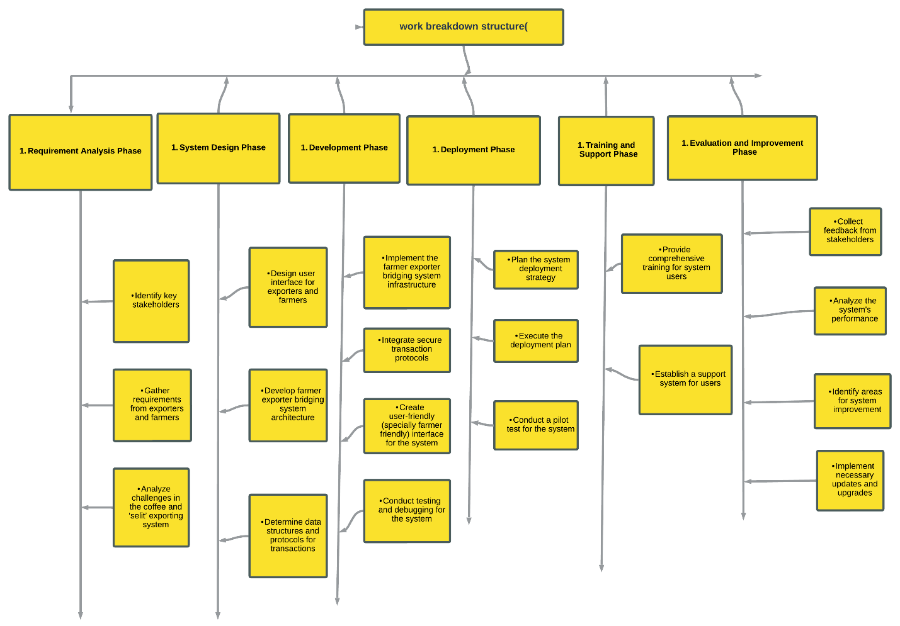

<https://lucid.app/lucidchart/58e950fd-3a6a-4863-9bed-6806ff9595e2/edit?viewport_loc=-4078%2C-1236%2C8368%2C3720%2C0_0&invitationId=inv_f7046f72-456a-40d5-87b8-5566dac926e3>

### 1.9.2 Gantt Chart

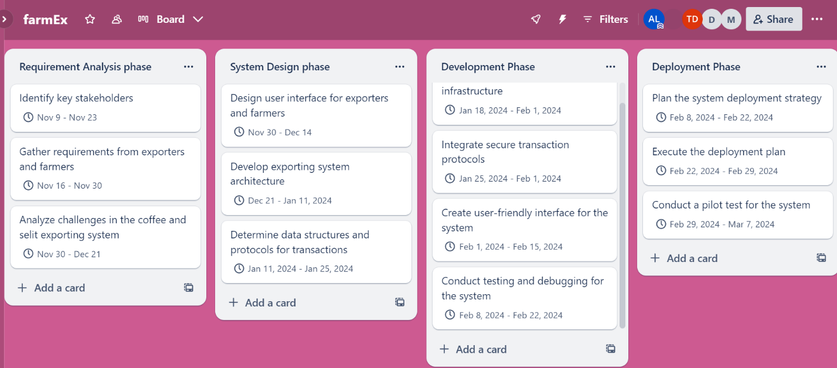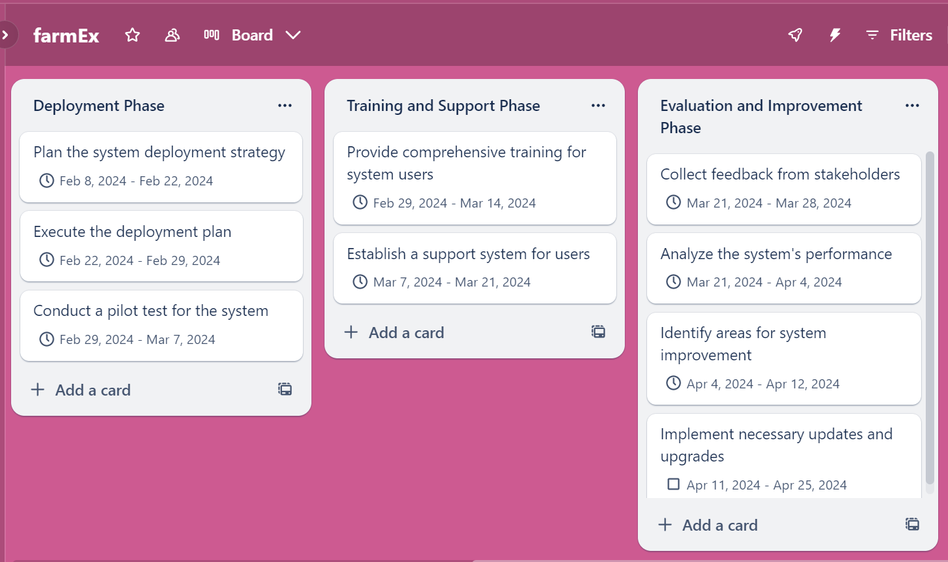

<https://trello.com/invite/b/5izQbpTp/ATTI1ad4a3eeeaec3ff80eabf4b5ad617c5aE93DFE93/farmex>

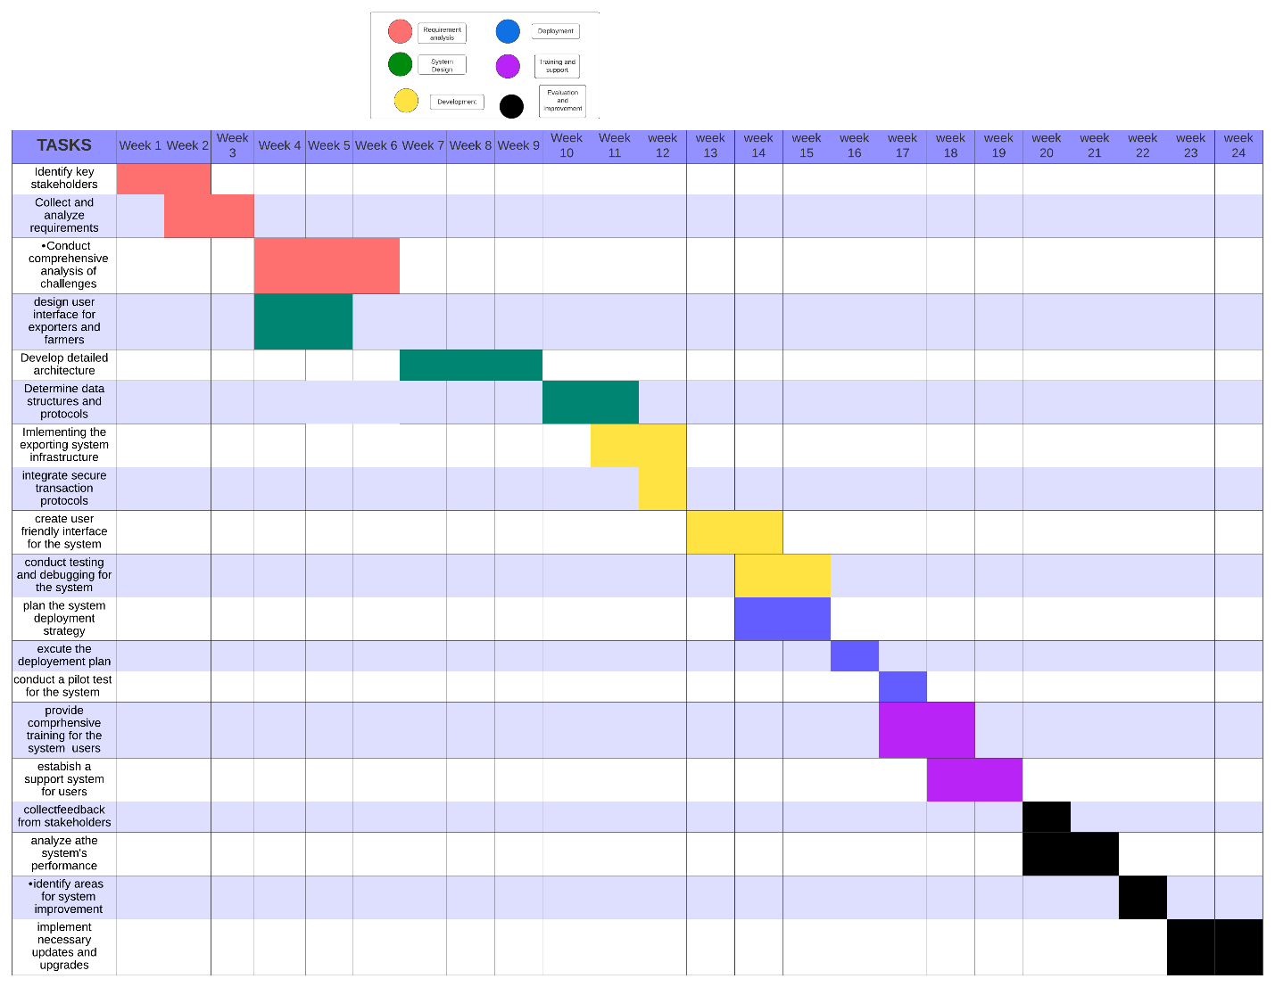

<https://lucid.app/lucidchart/58b865da-47a0-4b17-ad39-50e5461c9e5b/edit?viewport_loc=-2656%2C-1747%2C4080%2C1707%2C0_0&invitationId=inv_a53f88d2-2edb-4226-9142-9ae683f54237>

### 1.9.3 PERT/CPM CHART

|  |  |  |  |
| --- | --- | --- | --- |
|  |  | Estimated | Dependencies |
|  |  | Duration |  |
| Activity | Description | (Days) | predecessor |
|  | Identify key stakeholders | 14 | none |
|  | Gather requirements from exporters and farmers | 14 | A |
|  | Analyze challenges in the coffee exporting system | 21 | B |
|  | Design user interface for exporters and farmers | 15 | B, |
|  | Develop exporting system architecture | 21 | C, D |
|  | Determine data structures and protocols for transactions | 14 | E |
|  | Implement the exporting system infrastructure | 14 | F |
|  | Integrate secure transaction protocols | 7 | F |
|  | Create user-friendly interface for the system | 14 | F |
|  | Conduct testing and debugging for the system | 14 | H |
|  | Plan the system deployment strategy | 14 | H |
|  | Execute the deployment plan | 7 | K |
|  | Conduct a pilot test for the system | 7 | K |
|  | Provide comprehensive training for system users | 15 | G |
|  | Establish a support system for users | 15 | G |
|  | Collect feedback from stakeholders | 7 | M, L |
|  | Analyze the system's performance | 15 | P |
|  | Identify areas for system improvement | 7 | P |
|  | Implement necessary updates and upgrades | 14 | R |

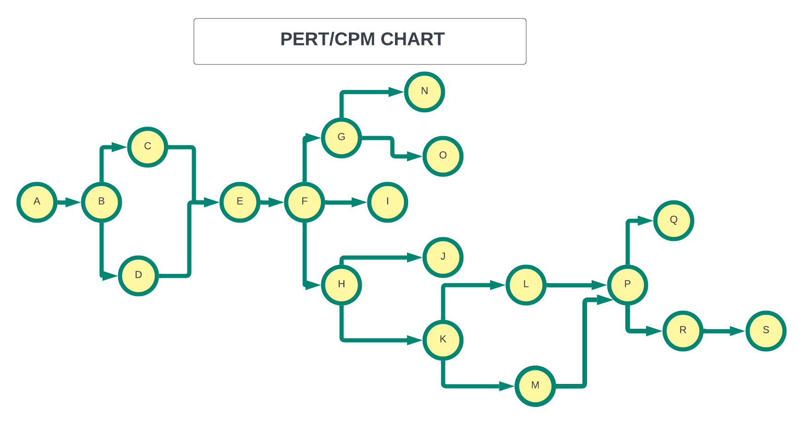

## 1.10 Risk Management

|  |  |  |
| --- | --- | --- |
| **Challenges** | **Impact** | **Mitigation** |
| Technical Challenges | Delays, increased costs, compromised functionality | * Feasibility study Experienced developers * Regular testing and debugging * Effective communication |
| Adoption and User Acceptance | Low usage, limited stakeholder participation, failure to achieve benefits | * User training and documentation * User involvement in design * User acceptance testing * Support |
| Data Security and Privacy | Confidentiality breaches, loss of trust, legal consequences, reputational damage | * Robust security measures * Compliance with regulations * Regular audits * Stakeholder education |
| Market Competition | Limited market share, reduced revenue, sustainability challenges | * Market analysis * Monitoring trends and user feedback * Value-added features * Sustainable mode |
| Change Management | Implementation delays, resistance, challenges in achieving desired outcomes | * Change management plan * Clear communication of benefits * Addressing concerns proactively |
| Resource | Delays, compromised quality, inability to deliver intended functionalities | * Resource assessment * Prioritization of activities * Resource allocation |

|  |  |  |
| --- | --- | --- |
| **Challenges** | **Impact** | **Mitigation** |
| Technical Challenges | Delays, increased costs, compromised functionality | * Feasibility study Experienced developers * Regular testing and debugging * Effective communication |
| Adoption and User Acceptance | Low usage, limited stakeholder participation, failure to achieve benefits | * User training and documentation * User involvement in design * User acceptance testing * Support |
| Data Security and Privacy | Confidentiality breaches, loss of trust, legal consequences, reputational damage | * Robust security measures * Compliance with regulations * Regular audits * Stakeholder education |
| Market Competition | Limited market share, reduced revenue, sustainability challenges | * Market analysis * Monitoring trends and user feedback * Value-added features * Sustainable mode |
| Change Management | Implementation delays, resistance, challenges in achieving desired outcomes | * Change management plan * Clear communication of benefits * Addressing concerns proactively |
| Resource | Delays, compromised quality, inability to deliver intended functionalities | * Resource assessment * Prioritization of activities * Resource allocation |

## 1.11 Communication Plan

Objective: To design and implement a digital platform connecting Ethiopian coffee and selit producers (farmers) with exporters, facilitating market access, pricing information, quality control, and empowering all stakeholders in the process.

**Key Stakeholders:**

* Project Development Team
* Coffee and Selit Farmers
* Ethiopian Coffee Exporters
* Ethiopian Selit Exporters
* Agents (Providing Guidance to Farmers)
* Ethiopian Regulatory Authorities (as needed)
* Project Management

**Communication Channels:**

|  |  |
| --- | --- |
| Communication Channel | Description |
| Project Team Meetings | Regular team meetings (weekly/bi-weekly) for status updates, issue resolution, and scope change discussions. Use video conferencing or collaboration tools for remote team members. |
| Email Communication | For formal project updates, reports, and documentation. Use distribution lists for relevant stakeholders, including management and regulatory authorities. |
| Online Collaboration Tools | Utilize tools like Slack, Microsoft Teams, or other messaging apps for real-time communication, quick questions, and notifications. |
| Project Management Software | Use project management tools like Asanasor Jira for task tracking, progress reporting, and scope change tracking. |
| Stakeholder Meetings | Regular meetings with farmers, coffee exporters, selit exporters, and agents to provide project updates, gather feedback, and address concerns. These meetings can also include educational components to help users adapt to the digital platform. |
| Official Documentation | Maintain a shared document repository (e.g., Google Drive, SharePoint) for project documentation, requirements, and reports. |
| SMS and Mobile Communication | Recognize that not all stakeholders may have access to email or online tools. Utilize SMS or mobile messaging for quick updates and alerts to reach farmers and other stakeholders effectively. |

**Communication Goals:**

Ensure all project team members are informed about project progress and changes.

Keep Ethiopian farmers, coffee exporters, selit exporters, and agents updated on system developments and changes.

Share key project milestones and timelines with management and regulatory authorities.

Provide a clear process for managing scope changes and updates.

**Responsibilities:**

**Project Manager:** Overall project communication and coordination.

**Team Members**: Share progress updates, issues, and propose scope changes.

Stakeholders (Farmers, Coffee Exporters, Selit Exporters, Agents): Provide feedback, report issues, and request information.

**Management and Regulatory Authorities**: Oversee the project, make decisions based on updates, and ensure compliance with regulations.

**Scope Change Control Board:** Evaluate and approve/reject scope change requests.

**Scope Change Management:**

Follow the defined process for submitting and evaluating scope change requests.

Appoint a Change Control Board (CCB) to assess and approve/reject change requests.

Thoroughly assess the impact of scope changes on the project schedule, budget, and quality.

Maintain detailed records of all change requests and decisions.

Communicate the status and impact of scope changes to all stakeholders.

Ensure that scope changes do not compromise the quality of deliverables.

Regularly review and update the risk management plan to address new risks introduced by changes.

Continuously monitor the project for additional scope changes and maintain accurate project documentation.